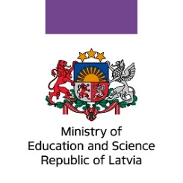

EEA Grants 2014-2021
Baltic Research Programme
Programme Committee meeting
20-21 Norway 2019 Riga

ANDRES MERITS (CHAIR), EE NATURAL SCIENCES
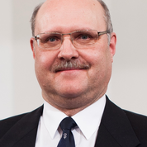
Andres Merits is Professor of Applied Virology and Academy Research Professor at the University of Tartu (Faculty of Science and Technology, Institute of Technology).
Field of research: Biosciences and Environment; Microbiology, bacteriology, virology, mycology
Research interests: replication of different RNA genomic viruses and construction of virus-based gene expression vectors; construction of systems for antiviral drug screening (Chikungunya virus, Zika virus) and analysis of antiviral properties of low molecular weight compounds and oligonucleotide-based inhibitors.

RAIVO VILU, EE NATURAL SCIENCES
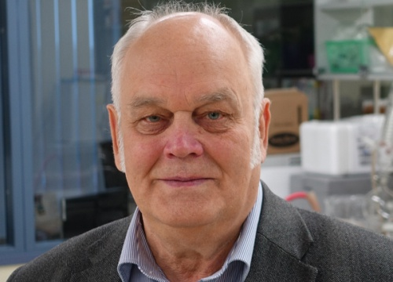
Raivo Vilu is Founder and Research Professor of the Competence Center of Food and Fermentation Technologies. Member of the Council of Institute of Chemistry, Tallinn University of Technology.
Field of research: Biosciences and Environment; Biotechnology, Molecular Biology, Cell Biology, Biophysics and Economic and Technological Research relating to Bio- and Environmental Sciences
Research interests: systems biology of bacteria, development of optimized biotechnological processes and creation of novel strains of bacteria applicable in dairy industry; promotion of Estonian food and integration of food with the scientific worldview.

MAIJA DAMBROVA, LV MEDICAL AND HEALTH SCIENCES
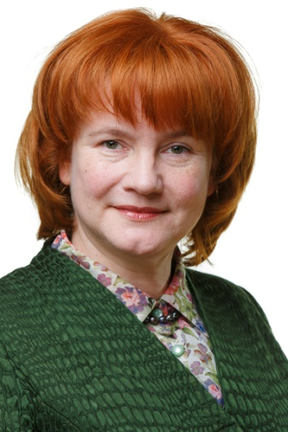
Maija Dambrova is Professor at the Department of Pharmaceutical Chemistry, Riga Stradins University, and Head of Laboratory of Pharmaceutical Pharmacology in the Latvian Institute of Organic Synthesis.
Field of research: Pharmaceutical and Biomedical Sciences, Pharmaceutical pharmacology
Research interests: pharmacology, molecular mechanisms and medicinal chemistry related to the anti-ischemic drugs with novel mechanisms of action, cellular energy metabolism, and inflammation; diabetes medicines and cardiovascular drugs.

LIMAS KUPČINSKAS, LT MEDICAL AND HEALTH SCIENCES
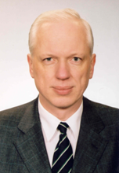
Limas Kupčinskas is Professor at the Gastroenterology Department at the Lithuanian University of Health Sciences. For many years served as Head of Gastroenterology Clinic.
Field of research: Medical sciences, Gastroenterology
Research interests: inflammatory and oncological disease biomarkers and microbiota in the digestive system and in the liver, and the search of new diagnostic and treatment methods for diseases of the aforementioned systems.

TĀLIS JUHNA, LV ENGINEERING AND TECHNOLOGY
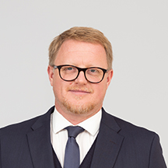
Tālis Juhna is Vice-Rector for Research at the Riga Technical University. Earlier Head of Water Research Laboratory in the Institute of Heat, Gas, and Water Technology.
Field of research: Environmental engineering, water technology
Research interests: drinking water treatment; removal of natural organic matter; iron and manganese removal from groundwater; bacterial growth in water distribution networks; rapid methods for identification of pathogens in drinking water; energy positive wastewater treatment plant.

MINTAUTAS GUTAUSKAS, LT HUMANITIES
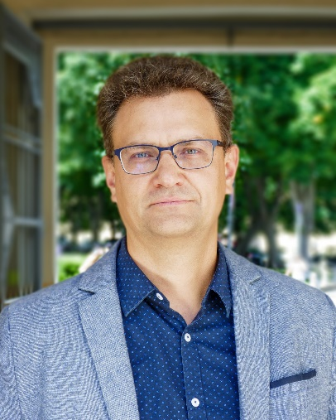
Mintautas Gutauskas is an Associated Professor and
Senior Researcher at the Vilnius University.
Field of research: Philosophy

Research interests: Phenomenology, hermeneutics, philosophy of language, anthropological difference and Anthropocene.

MARIANNE NORDLI HANSEN, NO SOCIAL SCIENCES
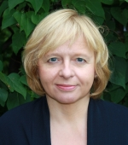
Marianne Nordli Hansen is Professor at the Department of Sociology and Human Geography, Faculty of Social Sciences, University of Oslo.
Field of research: Sociology
Research interests: sociology, social stratification, social class, education, economic inequalities, elites

MARTIN EISEMANN, NO SOCIAL SCIENCES, HEALTH
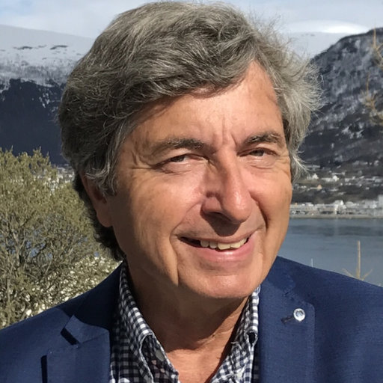
Martin Eisemann is Professor at the Department of Psychology at the UiT Arctic University of Norway
Field of research: Psychology
Research interests: personality, internet-based mental health preventions, parental rearing, vulnerability models, health-related quality of life, clinical psychology, alcohol abuse, health care outcome research, perceived safety.

